Transfer of Residence Ireland: A Complete 2026 Guide.
cormac658
Mar 6
3 min read
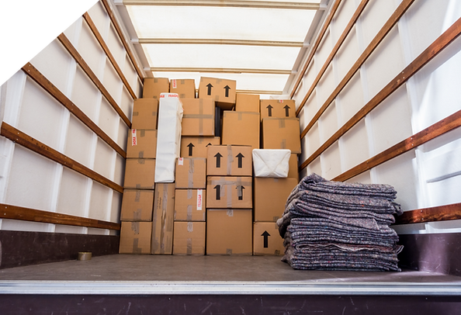
If you are moving to Ireland from outside the European Union, you may be entitled to bring your personal belongings into the country without paying Customs Duty or VAT. This is known as Transfer of Residence (ToR) relief. The rules can appear technical and confusing, and mistakes often lead to delays, unexpected charges, or goods being held at port. Understanding how Transfer of Residence works in Ireland in 2026 can save time, stress, and money.

Transfer of Residence relief allows individuals who are transferring their normal place of residence to Ireland to import their personal property free from Customs Duty and VAT. It most commonly applies to Irish citizens returning home after living outside the EU, individuals relocating to Ireland for employment, or families moving permanently from a non-EU country. Without ToR relief, household goods may be subject to customs charges based on their declared value, which can be significant depending on the shipment.

To qualify for Transfer of Residence relief in Ireland, you must generally have lived outside the EU for at least twelve consecutive months prior to your move. The goods being imported must have been in your possession and used by you for at least six months before the date you transfer your residence. You must be moving your normal place of residence to Ireland, and the goods must be intended for personal use rather than commercial purposes. Revenue assesses each application individually and may request supporting documentation to verify eligibility. It is important to understand that ToR relief does not apply to alcohol, tobacco products, or goods intended for business use, and specific rules apply in relation to vehicles.

The types of goods that can normally be imported under Transfer of Residence relief include household furniture, clothing, personal belongings, electrical appliances, and provided the conditions are met, a personal vehicle. The shipment should reflect a genuine move of residence. Large volumes of brand-new or unused items can raise concerns with authorities and may result in additional scrutiny (or documentation requests) from customs authorities. As a result, it’s all the more crucial to ensure that your logged inventory accurately reflects your used personal belongings.

When applying for Transfer of Residence in Ireland, documentation is critical. You will typically need proof that you lived outside the EU for the required period (12 consecutive months), such as utility bills, a tenancy agreement, or an employment contract. You will also need evidence of your move to Ireland, which may include proof of your Irish address, PPS number, or employment details. A detailed inventory of the goods being imported is required (as mentioned above), along with confirmation that the items were owned and used for at least six months. Incomplete or inconsistent documentation is one of the most common reasons for delays in approval.

Applications for ToR relief are made to Irish Revenue either before or at the time your goods arrive in Ireland. The process involves submitting the relevant application and supporting documents, followed by correctly declaring the goods on import. If the application is approved and all customs declarations are accurate, the goods can be cleared without payment of duty or VAT. However, if there are errors in the declaration, missing paperwork, or unanswered questions regarding eligibility, shipments can be held at port and storage charges may begin to accumulate.

Processing times for Transfer of Residence approval vary depending on the complexity of the case and the levels to which the documentation provided are completed. Straightforward applications with clearsupporting evidence are generally processed more quickly, while incomplete applications can experience delays. Planning ahead is essential, particularly if your household goods are already in transit.

Although it is possible to manage a Transfer of Residence application independently, many individuals choose to seek professional customs support to ensure the process runs smoothly. Accurate documentation, correct customs declarations, and clear communication with Revenue can significantly reduce the risk of delays, additional costs, or compliance issues. Relocating to a different country can be stressful enough, so avoiding customs complications can make the transition a lot easier
.

If you are planning a move to Ireland and want clarity on your Transfer of Residence eligibility, seeking the proper guidance can provide reassurance and certainty. At Customs Wise, we can help assist you or your family with Transfer of Residence applications, customs declarations, and the clearance of household goods into Ireland. If you would like support with your upcoming move, our team is ready to help ensure the process is smooth from start to finish.

